**EE 414 Lab 7 Report:**

**Assemble and Test Board**

**Due: December 10, 2021**

**By: Julio Torres, Johnathan Leisinger, and Prince Tshombe**

**Introduction**

For the 7th lab of the class, it was two weeks. We were given the board that we made before Thanksgiving breaks. In our board we added our amplifier design, dc bias design, and the bandpass filter design. We weren’t able to add our oscillator design because it wasn’t oscillating.

**Part 1: Amplifier Design**

**Here’s our Amplifier Design**

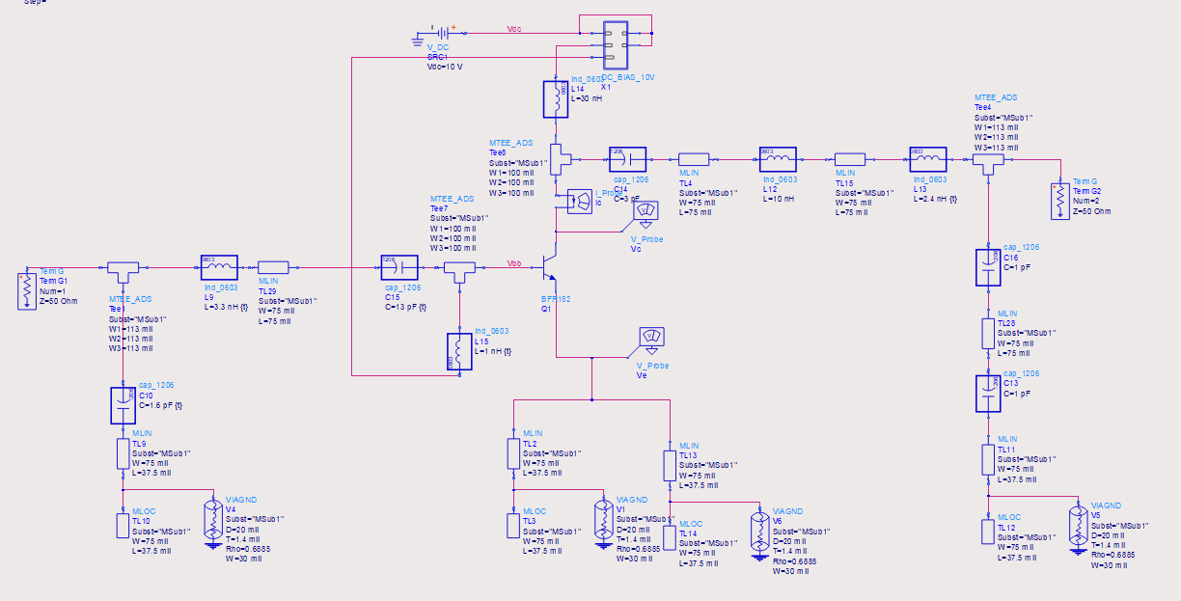

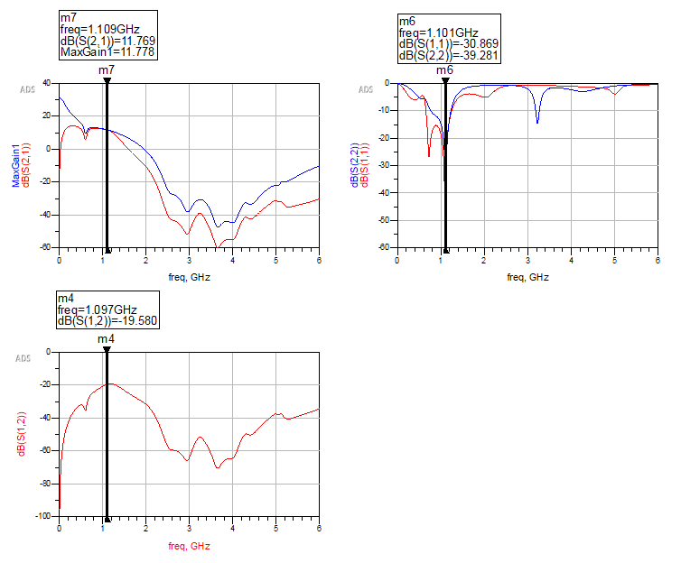

**Part 2: DC Bias Design**

**Here’s our DC Bias Design**

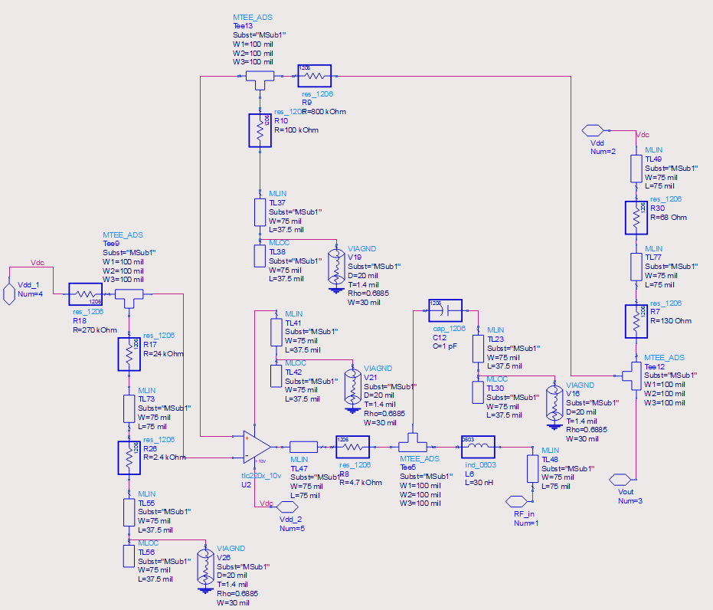

**Part 3: Bandpass Design**

**Here’s our Bandpass Filter Design**

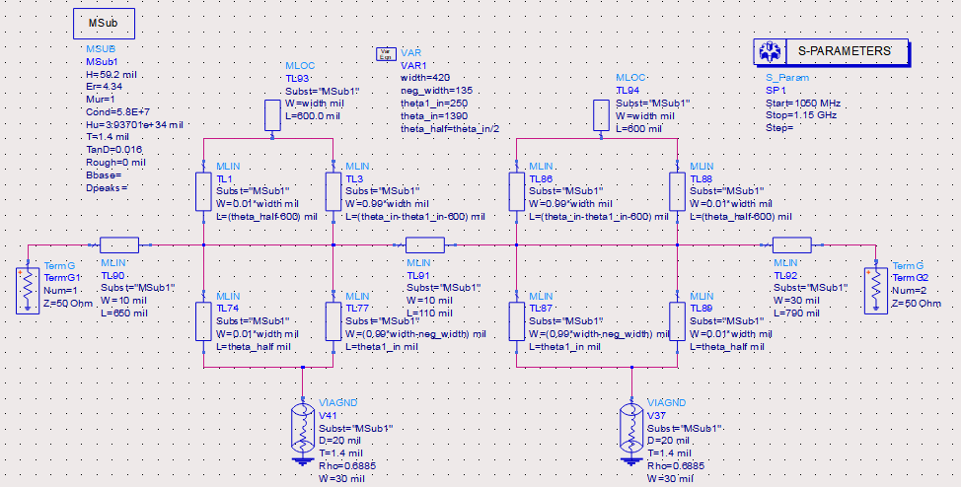

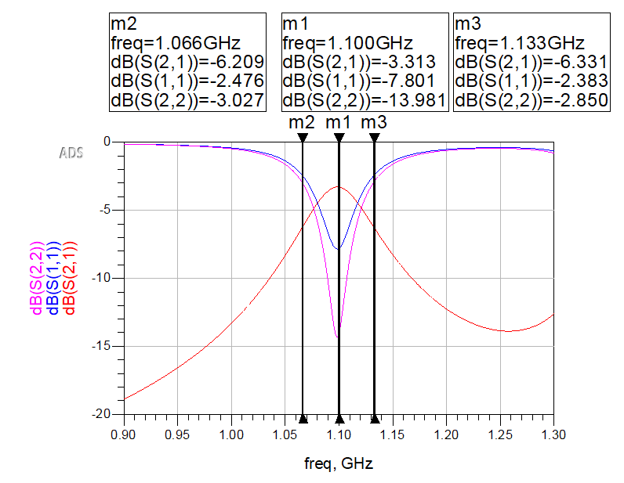

**Part 4: Layout**

**Here’s our Layout for the board**

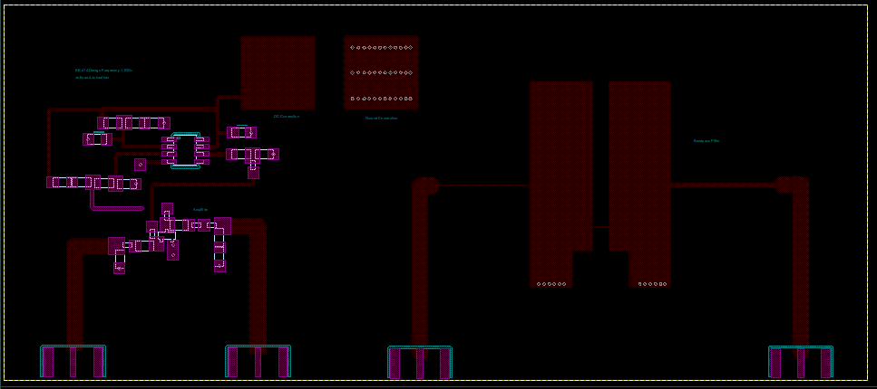

**Part 5: Board**

**Here's our board assembled.**

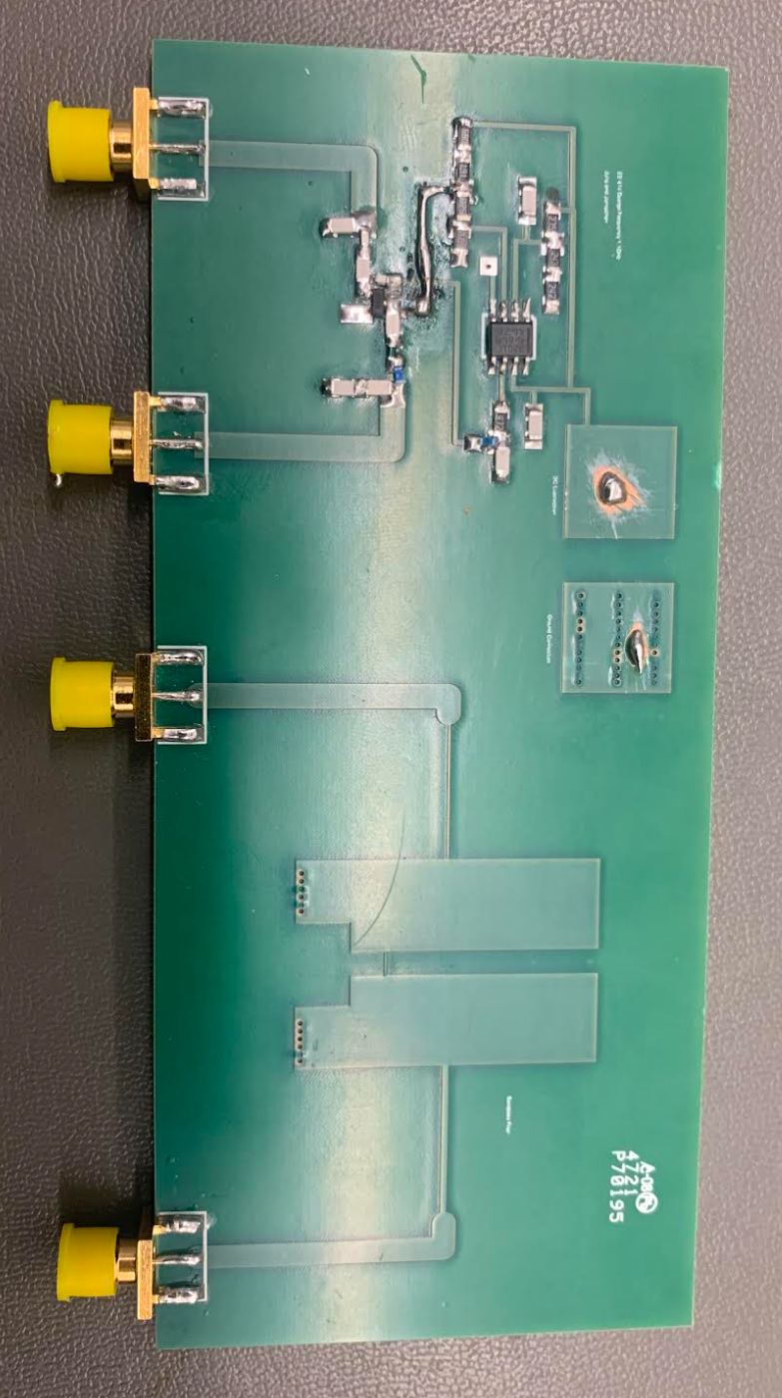

**Part 6: Test**

**Here are the results from our board:**

**Amplifier: Plot of measured |S11|, |S22|, and |S21| along with simulated values**

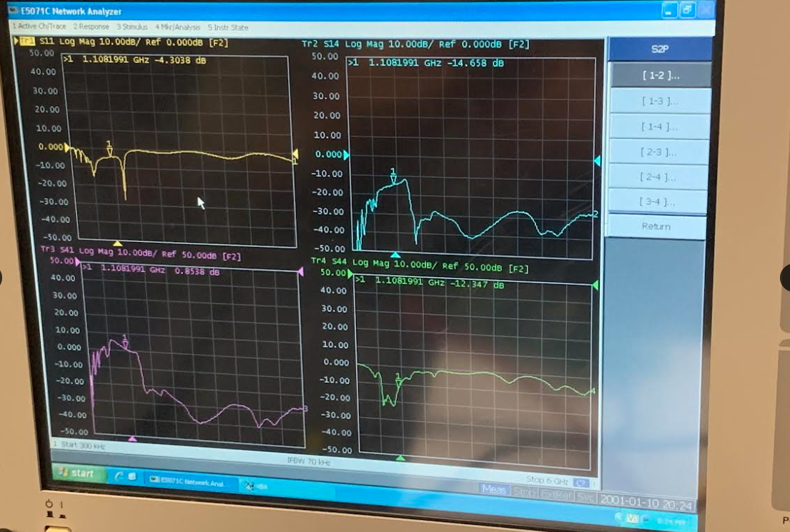

**Bandpass Filter: Plot of measured |S11| and |S21| of the filter along with simulated values**

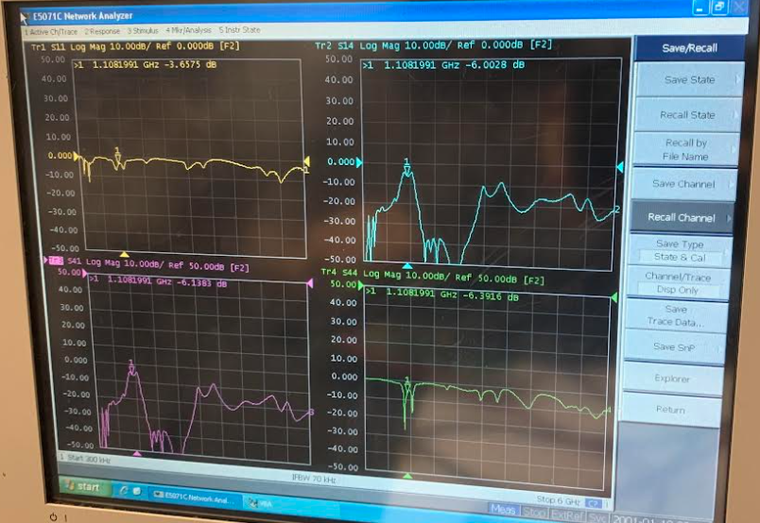

**Part 7: Conclusion**

Compared to the ADS simulations that we performed, the constructed amplifier’s S11 and S22 readings are out of sync and the gain was much worse than anticipated. We thought that the reason that we experienced these differences were due to components with slightly different values being used in the amplifier and DC bias circuit. The components that were different were:

* input matching network capacitor (1.5pF instead of 1.6pF)
* DC bias feedback series resistor paired with 1 MOhm parallel resistor (8.2 MOhm instead of 8 MOhm)
* DC bias Op Amp voltage divider series resistor paired with 264 kOhm parallel resistance (2.4 MOhm instead of 240 kOhm)

After accounting for these differences in ADS, only the 8.2 MOhm resistor made a difference. These differences were a large part of the shifting of S11 and S22 that we saw, as well as a subtraction of about 2.5dB of gain. This is largely due to the resistor lowering the voltage supplied to the base of the amplifier, whose gain is very sensitive to a change in voltage. We still do not know what is causing the other 9.5 dB loss in gain that we saw during testing.

The bandpass filter turned out much better than the amplifier. Compared to ADS, the fabricated filter had slightly lower gain (about 2.5 dB lower) and a slightly higher S11 (about 3 dB higher). However, the simulation data can be used on its own to show that the device being tested is a bandpass filter with a center frequency of around 1.1 GHz.